Submitting Claims via API November 2021

Use the Process Submissions to Send Claims
While this process should be scheduled for long-term success, it may be manually completed until the process is stabilized. Claims are sent via API interface after the submissions process is completed. Each claim run may submit 5000 claims or less. It may be necessary to schedule multiple claim runs per day. It is important to give enough time for the first submission to process completely before the next submissions process is kicked off.
To manually process claims, select Process Submissions from the Submissions & Remittance menu options in SurroundLab AR.

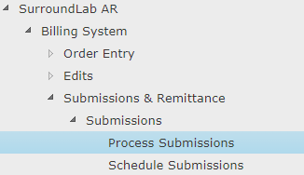

Select the Output Device of FILE and enter a unique File Name for the ECS Report that is generated when you Process Submissions for this form. Please make sure you do not duplicate a file name already created as there is no way to go back and create a new report without resending the claims from that submission.

Enter the Form Name you wish to process. Example: CHC ECS is the electronic claim submission form which sends claims via API to Change Healthcare. Other forms include: Client Statements queued by the Month End Close process, Patient Statements, etc.

Select Print from the end of screen buttons.

In the designated folder on the share drive, the ECS Report will be created with the file name chosen. This report provides an overview of the claims sent including a breakdown by payer.
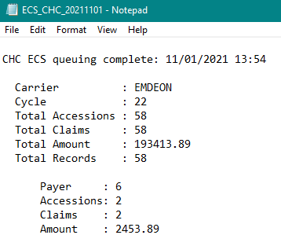
Also, included is a list of accessions/invoices/patients which were successfully sent in the ECS process.
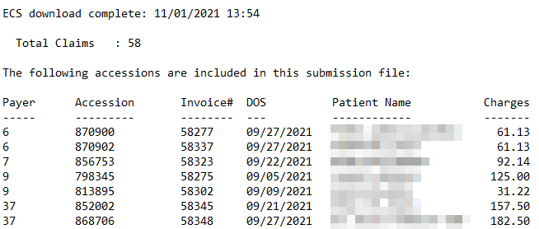
Also included in the ECS Report is a list of exceptions that could not be sent combined with a list of claims rejected by the clearinghouse based on payer requirements. This section can be easily copied and posted into Excel and formatted using a Text to Columns function.
Seacoast is exploring a worklist option to replace this effort.
This list should be reviewed and worked daily to confirm all claims are submitted timely.
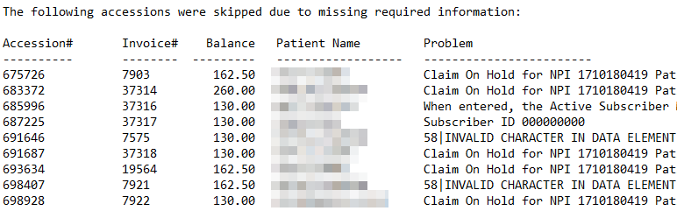
Note: Because the API interface which submits also receives rejections, the process takes a little while to complete. The file size will be updated when the process is completed. If the file size is zero then check back later to review.
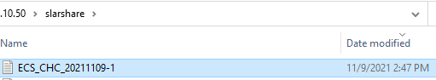

Reviewing Claims which Failed to Submit or Rejected by the Clearinghouse
Locate the most recent file. Scroll down to the section where the skipped claims are displayed.
Highlight the Header Data by clicking in front of the Accession #. Then, use Shift + End to highlight the row.
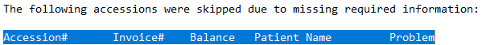
Then, using the Shift + Control + End, you can highlight the entire list of failed claims.
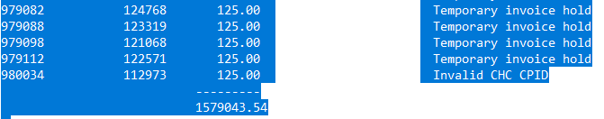
Copy and paste into an Excel worksheet. Under the Data options, select Text to Columns.
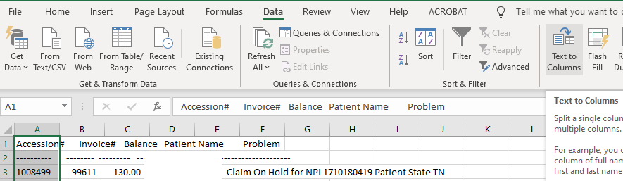
Use the Wizard to quickly update the data format. Choose Fixed Width. Next.
In Step 3, scroll the bar at the bottom to remove any unwanted line breaks. If any appear after 60 then double-click to remove them or the data will be separated into columns which is not desired.
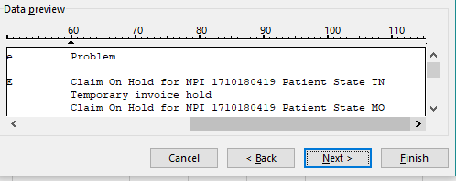
Select Finish to create new columns. Excel options are now available as usual.
Before pivoting, you may want to delete Column 2.

Then, any Excel function that you wish may be used to analyze the results. Pivot and double-click
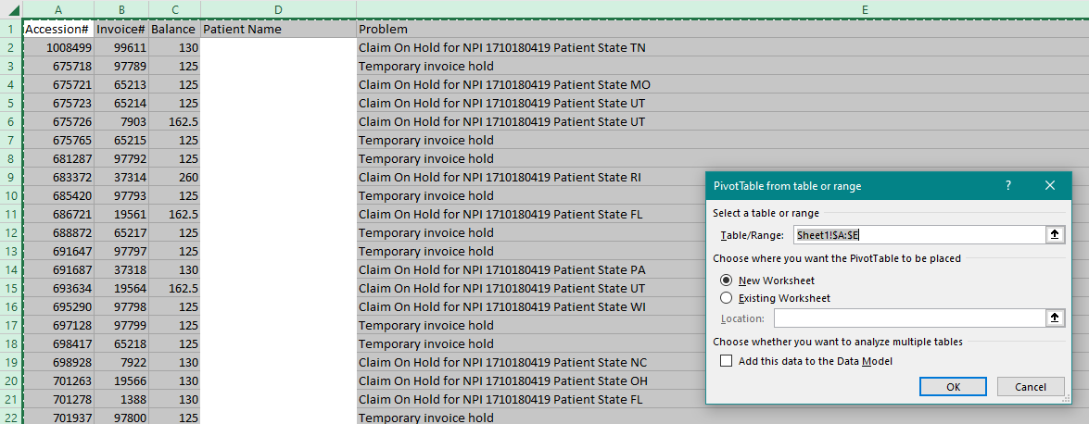
The high level data is visible in the table with a sort from largest to see the bigger issues. To create and assign a worklist, double-click on any of the values. A new worksheet is created for just that data set.

